

COMP1710/6780 Stuweb Submission Guide

This is a quick guide for submitting assignment files to Stuweb.

# Setting up your Stuweb account

In order for your file space on Stuweb to be created, you must first log in to the CECS Student Registration and Marks System (STREAMS).

1. Navigate to https://cs.anu.edu.au/streams/.
2. Log in using your ANU uid and password.
3. Log out.

# Setting up remote access to ANU Intranet

If you are off campus (no matter whether you are in Australia or overseas), please first set up an ANU VPN by following the steps in the following link (Please use GlobalProtect instead of Anyconnect): <https://services.anu.edu.au/information-technology/login-access/remote-access/download-globalprotect-for-windows-or-mac>

Note: If you cannot get ANU VPN work on your machine, please refer to

MacOS: https://services.anu.edu.au/information-technology/login-access/remote-access/remote-access-installation-macosfor other methods.

Windows: https://services.anu.edu.au/information-technology/login-access/remote-access/remote-access-installation-windows

# Submission Methods

The following submission methods will vary based on your computer’s operating system. There are instructions for submitting files to Stuweb via Mac OSX/Ubuntu and Windows Operating System.

Note: You must place your assignment files into the public directory (folder) provided in your Stuweb account, which is **/webusers/uni_id/public_html** (please don't change the name of the folder or it will not work). Files in this folder are visible to users on the ANU intranet (but not to users on the wider Internet).

## Method 1: From a Mac OSX Terminal/Ubuntu

1. Open the Terminal by hitting command ⌘ + space bar, typing Terminal.

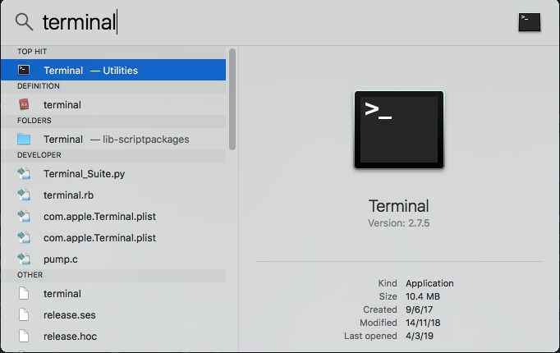

1. Hit enter. The following screen should show up.

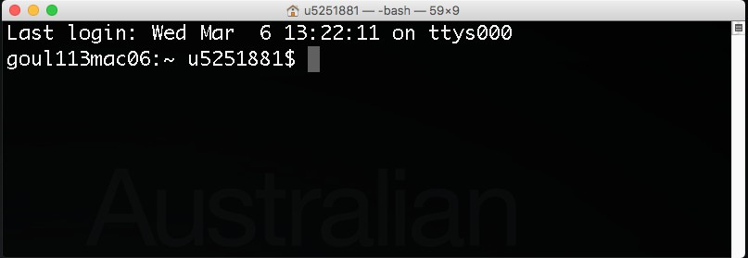

1. Navigate to the directory containing assignment files that you would like to upload to Stuweb. Some useful commands to help you do this are:
   1. Use the **ls** command to list the contents of the current directory
   2. Use the **cd** command to change directories (for example, **cd Desktop** to shift to go to the desktop folder, or **cd ..** to move up a level)

Example

Suppose you want to upload assignment.html to your Stuweb account, and the assignment.html file is stored in Desktop/ folder on your local computer.

Type **ls** to list the contents of the current directory

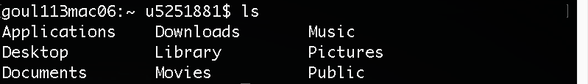

Type **cd Desktop** to navigate to the Desktop folder



Type **ls** to see if assignment.html is inside the current directory



1. Now since you have navigated to the directory where your assignment files are located, you can then use the secure copy command **scp** to upload your files to your Stuweb account by typing the following command:

scp filename uni_id@partch.anu.edu.au:/webusers/uni_id/public_html

Example

Suppose now you would like to upload assignment.html file to your Stuweb account and your uni id is uXXXXXXX.

Type the following command, hit enter.

scp assignment.html uXXXXXXX@partch.anu.edu.au:/webusers/uXXXXXXX/public_html

Type “yes” to the access question (only asked the first time only).

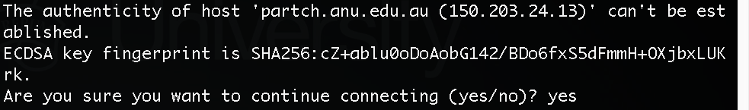

You will be asked to enter your password. This is an invisible prompt and will not show anything as you type.



You should be able to see upload status like this, which means you have uploaded the file!

1. If you want to copy all the files and subdirectories in the current local directory to a to your Stuweb account, you can type

scp -r * uni_id@partch.anu.edu.au:/webusers/uni_id/public_html

Note: There is a space between “scp” and “-r, “-r” and “*” , and “*” and “uni_id”.

1. Refer to verifying your files are uploaded correctly.

## Method 2: From a Windows Terminal

1. Download pscp.exe from PuTTY ([Download PuTTY: latest release (0.80) (greenend.org.uk)](https://www.chiark.greenend.org.uk/~sgtatham/putty/latest.html)
2. Put pscp.exe into the folder where your assignment files are stored.
3. Open the Windows command prompt, by hitting Win + R, type cmd and hit enter
4. Navigate to the directory containing assignment files that you would like to upload to Stuweb. Some useful commands to help you do this are:
   1. Use the **dir** command to list the contents of the current directory
   2. Use the **cd** command to change directories (for example, **cd Desktop** to shift to go to the desktop folder, or **cd ..** to move up a level)

Example

Suppose you want to upload assignment.html to your Stuweb account, and the assignment.html file is stored in Desktop/ folder on your local computer.

Type **cd Desktop** to navigate to the Desktop folder, and type **dir** to see if assignment.html is inside the current directory

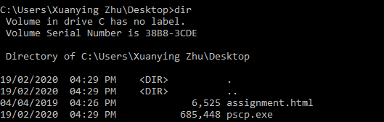

1. Now since you have navigated to the directory where your assignment files are located, you can then use the secure copy command **pscp** to upload your files to your Stuweb account by typing the following command:

pscp filename uni_id@partch.anu.edu.au:/webusers/uni_id/public_html

Example

Suppose now you would like to upload assignment.html file to your Stuweb account and your uni id is uXXXXXXX.

Type the following command, hit enter.

pscp assignment.html uXXXXXXX@partch.anu.edu.au:/webusers/uXXXXXXX/public_html

Note: If you see an error message with “ssh_init: Network error: Cannot assign

requested address”, please try the following command

pscp -P 22 assignment.html uXXXXXXX@partch.anu.edu.au:/webusers/uXXXXXXX/public_html

Type “y” to the access question (only asked the first time only).

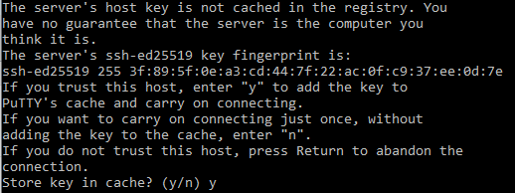

You will be asked to enter your password. This is an invisible prompt and will not show anything as you type.



You should be able to see upload status like this, which means you have uploaded the file!

1. If you want to copy all the files and subdirectories in the current local directory to a to your Stuweb account, you can type

pscp -r * uni_id@partch.anu.edu.au:/webusers/uni_id/public_html

Note: There is a space between “pscp” and “-r, “-r” and “*” , and “*” and “uni_id”.

Note: If you see an error message with “ssh_init: Network error: Cannot assign requested address”, please try the following command

pscp -P 22 -r * uni_id@partch.anu.edu.au:/webusers/uni_id/public_html

1. Refer to verifying your files are uploaded correctly.

## Method 3: Graphical User Interface

By using this method, a third party application is required to provide the means to view and move files in folders using icons, akin to Windows Explorer or Mac OSX Finder.

1. Download and install an SCP/SFTP client.

For Mac OSX, Cyberduck is a good client to download.

For Windows, WinSCP is a good client to download. Cyberduck is also available for Windows.

1. Connect to Stuweb Open a new connection, and enter the following details: File Protocol: SFTP (or SCP)

Host name: partch.anu.edu.au

Port number: 22

User name: <your uni id> Password: <your password>

Hit Login/Connect.

1. Transfer files

The application will open you with a GUI representation of your files currently on Stuweb. Open a Windows Explorer or Mac OSX Finder window, browse to your files, and drag and drop these onto Stuweb. Make sure you are putting them in the

**/webusers/uni_id /public_html** folder.

# Verifying your files are uploaded correctly

There are two ways of verifying if your files are uploaded correctly.

## Method 1: via a browser

Enter the following URL into a web browser (remember to replace uXXXXXXX with your uni id)

From on campus: stuweb.cecs.anu.edu.au/~uXXXXXXX/

Use the above method if you are using a computer connected to the ANU network. This includes CECS computers in the CSIT building, or ANU IT Services computers in the COMP1710 lab room and ANU libraries.

From off-campus: stuweb.cecs.anu.edu.au.virtual.anu.edu.au/~uXXXXXXX/

Use the above method if you have connected your personal device to the ANU-Secure Wi-Fi network, or to the ANU network via the ANU VPN, or any non ANU network. You will be asked to log in using your username and password to use ANU’s reverse proxy.

Note: If you have received 403 Forbidden HTTP status codes when attempting to view your web pages, that is because your files have not been granted with correct permissions. To solve this, please follow the procedures in Method 2: via SSH.

## Method 2: via SSH

1. Connect to your Stuweb account on a terminal by typing (remember to replace uXXXXXXX with your uni id)

ssh [uXXXXXXX@partch.anu.edu.au](mailto:u1234567@partch.anu.edu.au)

and type “yes” to the access question (only asked the first time only) and type in

your password.



Now you should be able to see a screen like this. (Please note that the circled area says you are in Stuweb now)



1. Type the following command to navigate to your public_html folder, which the server will look at to launch your website

cd /webusers/uXXXXXXX/public_html



Note: You may see a public_html folder under /students/uni_id/, but that is NOT the folder we are after. Only files under /webusers/uni_id/public_html can be seen on a browser on the ANU intranet.

1. Then you can check the files by typing

ls -l



Now you should be able to see your assignment.html as above.

However, it is very likely that you may receive 403 Forbidden HTTP status codes when attempting to view your website. This is caused by your client not having the necessary privileges to view the content on Stuweb. So you have to change the file permissions.

1. Type the following command to change permissions for all files and any subdirectories

chmod -R g+r *



1. Type **ls -l** to check if the permissions are now correct. The fifth letter of the permission string (as circled) should be **r**.

